CST2355 – Database Systems Lab Assignment 7

Student Name: Yanzhang Wu__________________

Student ID: 41056465__________________

Student email: wu000298@algonquinlive.com__________________

# Hand-in:

1. The lab assignment will be graded out of a maximum 4 points.
2. This template should be used to submit your lab assignment.
3. Make sure you have enough screenshots to completely document that you have completed all the steps.

# Activities (Steps):

1. In this lab you will be using the Oracle (Version 19c) database management system, and Oracle SQL Developer (which gets installed as part of the 19c enterprise installation). The first step is to get the software installed.
   1. Download Oracle 19c Enterprise Edition.
      1. Please note that the two files are available in Brightspace through links under the “Oracle files” content area. This is an older version of Oracle that contains almost all of the current features, but will install on a Windows 10 laptop.
      2. Create an Oracle installation folder, using a folder name that is short and does not contain blanks. (e.g., C:\oracle19cinstall) Then, unzip the compressed file **into the Oracle installation folder**.
   2. Open a “cmd” window as administrator (i.e., **Select “Run as administrator”)**. Then, navigate in the cmd window to the folder (under your installation folder in step 2) where the setup.exe file has been unzipped. Then, run the following command.
      * 1. On Windows 10: **make sure you are running the command as administrator** and use the following command line. You need to have changed the working directory to the directory where the setup.exe program was unzipped. (Don’t just click on it in Windows Explorer….)

**setup -ignorePrereq -J"-Doracle.install.db.validate.supportedOSCheck=false"**

* + 1. The installation program is a Java executable, and is notoriously tricky. Sometimes it will pop-up a window underneath the main window; leaving you waiting forever because you did not realize that the program is waiting for a response.
    2. Respond appropriately to the installation customization queries. The critical steps are highlighted – they are mandatory for this course.
  1. Step 1: Configure Security Updates:
     1. Email option – leave blank, does not apply
     2. Deselect the update notification option. You do NOT want to receive security updates.
     3. Press 'Next'
     4. Ignore the warning, press 'Yes'.
  2. Step 2: Installation Option:
     1. Select 'Create and configure a database', then press 'Next'
  3. Step 3: System Class:
     1. Select 'Desktop Class', then 'Next'
  4. Step4: Home User Selection
     1. Select 'Use Built-in Windows Account, then press 'Next'
     2. Ignore the security warning and proceed.
  5. Step 5: Typical Installation Configuration:
     1. Accept defaults EXCEPT for the following:
        1. Global DB name: change to **'orcl'**
        2. ***CAREFUL: Make sure to uncheck the ‘create as container database” checkbox***
        3. Admin (SYS) password: '*yourFirstName*sOracle123' (e.g., dougOracle123)
           1. If you receive a warning('INS-30011') that your password strength is poor, ignore it
           2. 'Next' / 'Yes' to continue
  6. Step 6: Prerequisite Check is performed. This may take some time. Sometimes the installer will pop-up a window underneath a visible window (so that you cannot see the pop-up) so some manual intervention may be required.
  7. Step 7: Summary of response is displayed. 'Save Response File' and 'Install'.
  8. Step 8: Install Product message is displayed. If you receive a Windows firewall message, allow access for Java
     1. Several components are installed
     2. In the Password Management screen, change the password for user SYSTEM to : '*yourFirstName*system' (e.g., dougsystem). You may unlock and change passwords for some other accounts at the same time (or just leave them defaulted for now. The website <https://www.orafaq.com/wiki/List_of_default_database_users>

has a list of default Oracle usernames and default passwords.

* + 1. 'OK'
    2. Ignore any additional password standards warning message. 'Continue? Yes' / 'OK'
    3. Windows 10: If Services for Microsoft Transaction Server cannot start – that is OK. Click Next and Yes when asked are you sure you want to continue.
  1. Step 9 Installation was Successful message is displayed. **Take your screen shot before closing the window and paste it below** Then, select 'Close'
     1. **Paste your screen shot showing successful installation below**.

* 1. Confirm you are able to **connect** to the database**. (Open a cmd window using ‘run as administrator’ and run the ‘sqlplus / as sysdba’ command line.) Once connected, run the command ‘show con_name;’ which will show the connection name for your default instance. Here is mine:**

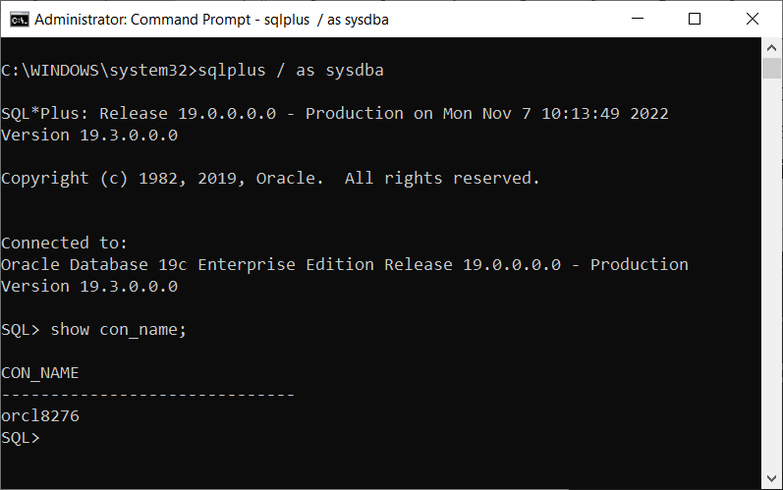

* 1. **Paste your session showing a successful connection below.**

|  |
| --- |
|  |

1. Now that Oracle is installed, we will use **sqlplus** to create the database and populate some test data using the scripts supplied in Brightspace for this lab.
   1. Copy the **lab7-create.sql** and **lab7-cleanup.sql** scripts to a convenient folder on your PC.
   2. Open a cmd window (‘run as administrator’) and navigate to the folder where your sql scripts are stored. (using the cd command….)
   3. Inside the command window, startup sql plus as follows: ‘sqlplus / as sysdba’
   4. This will again connect you as sysadmin without needing a password.
   5. Once connected, issue the following command inside sqlplus

@lab7-create.sql

* + 1. This should execute the script from the current folder, and create the database. **Please note: you should expect some error messages during the script; there are some data insertion errors that you will need to clean-up**, and some other changes to be made later in the lab. For now, just ensure that the script is found and that all is OK except for the errors caused by the failed inserts.
       1. Provide a screenshot of the initial run of the script.

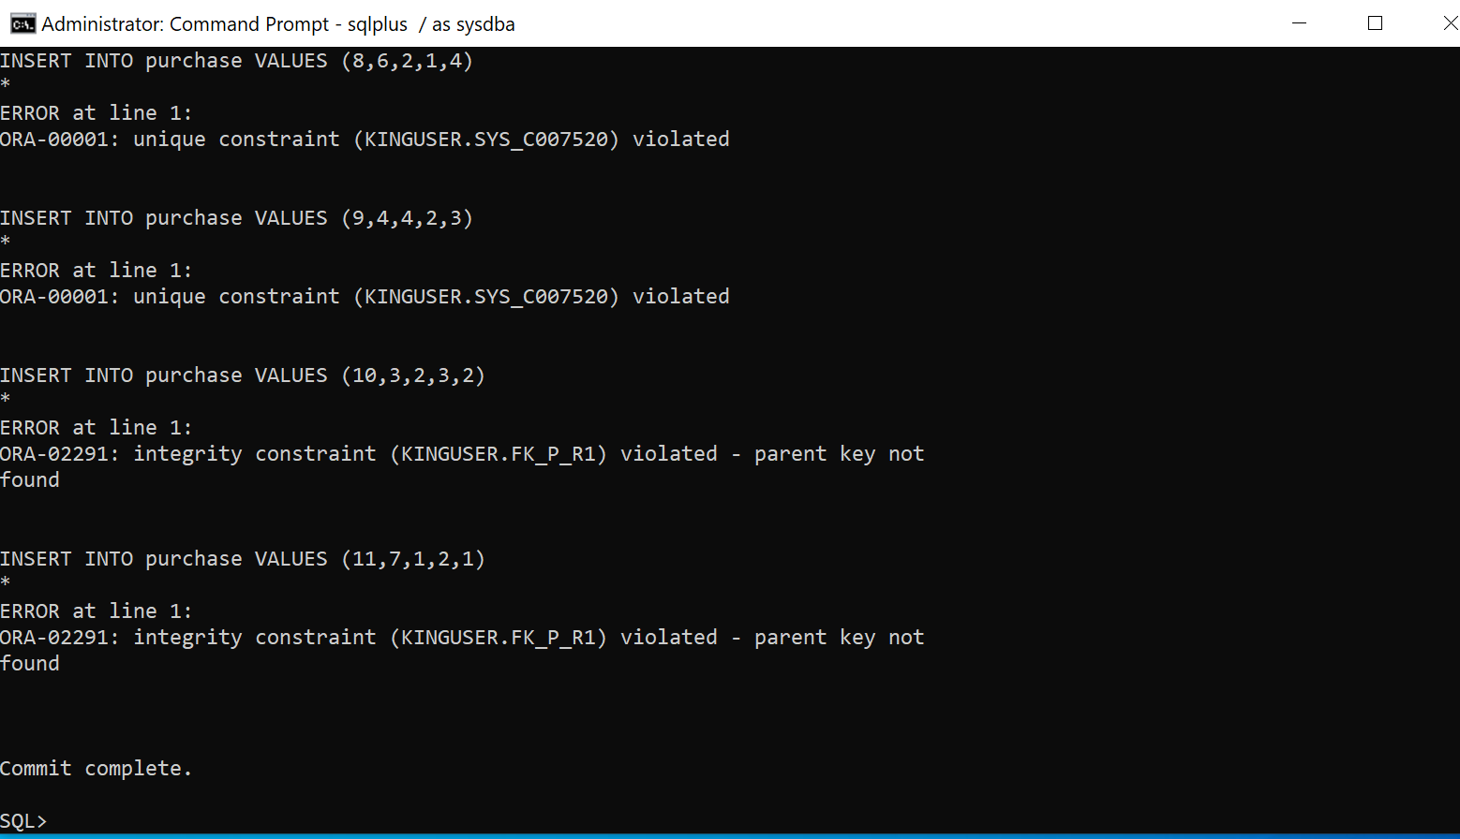

* + 1. Use sqlplus to run the script **lab7-cleanup.sql** using sqlplus. This will undo the effects of the first script.

1. Now you will fix the creation script. Open the lab7-create.sql script using a text editor and CAREFULLY make the following changes:
   1. Change the username for the user that is assigned the application administrator role to ‘*yourname*User’ and change the password for that user.
   2. Modify the insert statements to fix the invalid telephone numbers and postal codes.
   3. Update the trigger on the retaillocation table to include both a check on postalcode and a check on the telephone number. Provide a screenshot of your updated trigger below:

1. Use a texteditor to edit the **lab7-cleanup.sql** script to be able to cleanup based on your new *yourname*Userusername. Provide a screenshot showing the updated contents of the script below

1. Create a screenshot showing you running your version of the lab7-create.sql script and including (some of) the output. You now have the storage, user, roles, tables, triggers, and stored procedures all in place. Provide the screenshot below:

lab7-create.sql execute without error

Use select * from retaillocation to check the output. The result matches the records in the script.

1. Use the Windows Start menu to open the ‘Oracle SQL Developer’ tool in the Oracle tools folder. You should see something like this:

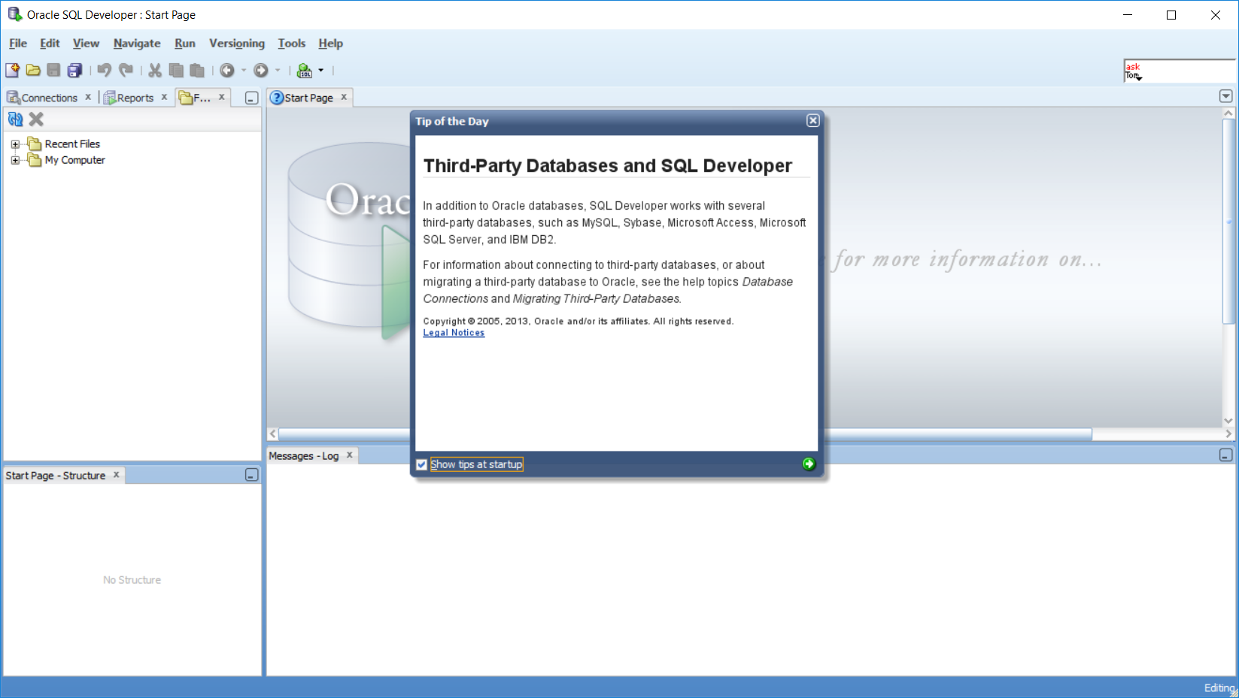

* + 1. You need to create a new connection called *yourname*UserConnectionthat connects to the local Oracle database instance as *yourname*Userusing the password you used in the creation script.
       1. Click on the new connection button.You should see something like this:

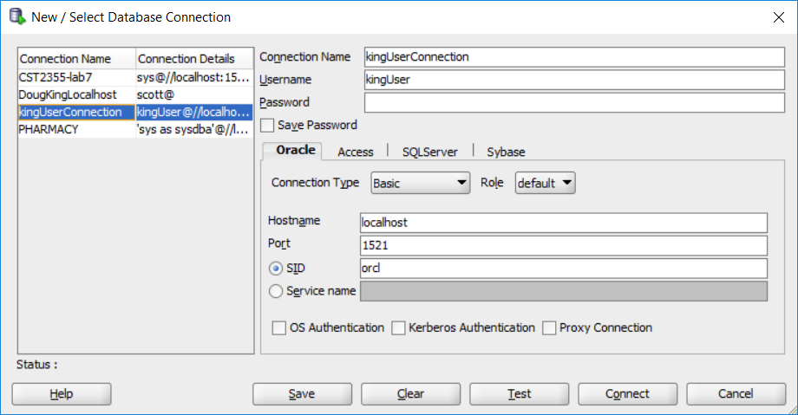

* + - 1. You likely have less database type options, but you should fill in the form: select ‘Oracle’ and change the SID to the instance name that you had captured earlier (‘show con_name’ using sqlplus). Mine is ‘orcl’. You should test your connection and provide the confirmation screen below.

* + 1. Once the connection is in place, Open it (providing the password for your new user) to view the contents. Provide a screenshot showing the set of tables.

* + 1. Use the query editor in SQL Developer (or sqlplus) to provide examples of trying to insert an invalid address, an invalid telephone, and a retaillocation with both problems. Provide your screenshots below.
       1. Invalid address (postalcode):

* + - 1. Invalid telephone:

* + - 1. Invalid retaillocation: (3 possibilities)
         1. Invalid telephone field:

* + - * 1. Invalid postalcode field:

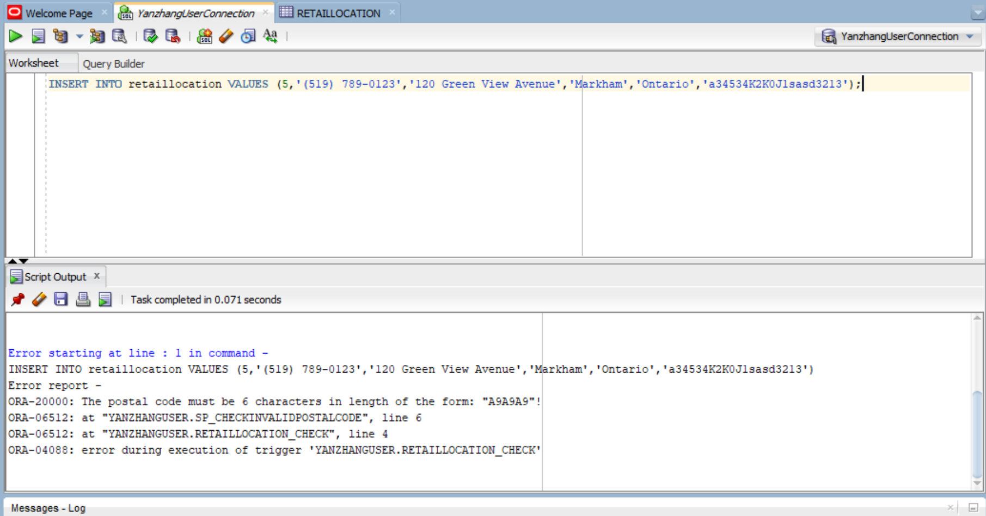

* + - * 1. Both postalcode and telephone are invalid (don’t try to fix the trigger… it is ok if only 1 error is shown):

1. Once you have embedded all of your screenshots, submit the file in Brightspace and you’re done!